**Project:** CGFacilities

**General information:**

We have 2 projects configured in the application:

* Front end with Angular named as “POC”

This project is related to the front end of the application where user can work using the User Interface.

* Services as backed named as: “POCAPI”

This project handles the rest based services which are responsible to pass the calls of front end operation to the database

**Guidelines to get the published contents for both the projects to host on IIS:**

* Please open the solution of the application inside Visual Studio 2015 or above version.
* Please download and install nodejs from <https://nodejs.org/en/download/>. Please install the “Recommended for most users” only and not the “Current”.

**To get the publish contents of the POCAPI project:**

* Please go to the API project and change the connection string to your database inside web.config file which is in the root directory of the project. This is the connection string which is needed to be changed highlighted in bold below :

<add name="FacilitiesEntities" connectionString="metadata=res://*/POCEntity.csdl|res://*/POCEntity.ssdl|res://*/POCEntity.msl;provider=System.Data.SqlClient;provider connection string=&quot;**data source=173.248.153.60,1533;initial catalog=Facilities;persist security info=True;user id=FacilitiesUser;password=CP9p4Oietj3Ai;**multipleactiveresultsets=True;application name=EntityFramework&quot;" providerName="System.Data.EntityClient" />

* Please right click on the API project (Service application) and click publish to get the published files (only File system)
* This will create a folder with published contents in it.
* Please deploy these files on IIS

**To get the publish contents of the angular project:**

* Inside the angular project please open go to  src/app/components/ and open "app.globalvariables.ts" file
* change the API service link to the URL of your hosted API on your IIS .i.e value of "readonly baseAPIUrl: string = 'URL OF API HOSTED IN IIS' "
* Please open node command prompt after installing the nodejs on your system
* Please go to the root directory of the angular project in command prompt
* run "ng build" command in the command prompt
* (This command will create "**dist**" folder inside the root directory of angular application which contains published files of angular application)
* Please open index.html file and change  "<base href="/">" to "<base href="">"
* Please deploy these files on IIS

**Guidelines to deploy the published contents on the IIS:**

* Please open IIS using either “inetmgr” or “IIS” on the windows Run command. (Windows button + R )
* Please expand the default sites node in the IIS manager as shown below:

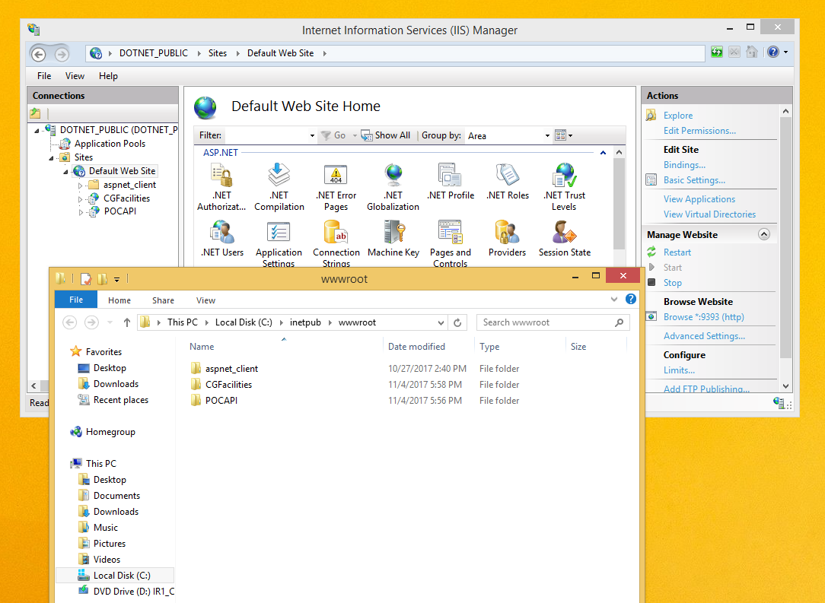

* Right click on “Default Web Site” node and click “Expand”. This will take you to the default port location of IIS where we can deploy the site and services. The location generally is “C:\inetpub\wwwroot”.
* Please Create 2 folders here, 1 for angular application and 1 for services. For example as shown in the image above, we have created 2 folders, CGFacilities for angular project and “POCAPI” for services.

**Steps for deploying the angular application:**

* Please copy all the contents of the “dist” folder inside the angular folder “CGFacilities” created as illustrated above.
* In the IIS manager right click on the “CGFacilities” node and click on “Convert to application” node in the pop up. You will be presented a dialog box “Add Application” thereafter.
* Please click on OK and we should be all ready now. The application is hosted on IIS.
* To check the working. Please click on the “CGFacilities” node and click “Manage application” and browse as show below:

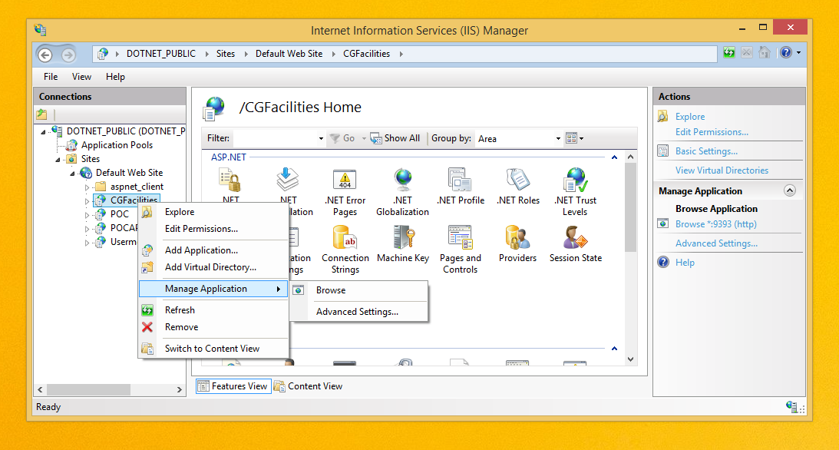

**Steps for deploying the angular application:**

* Please copy all the published contents of the services inside the folder “POCAPI”.
* In the IIS manager right click on the “POCAPI” node and click on “Convert to application” node in the pop up. You will be presented a dialog box “Add Application” thereafter.
* Please click on OK and we should be all ready now. The services are hosted on IIS.
* To check the working. Please click on the “POCAPI” node and click “Manage application” and browse as we checked the angular application deployed.